

CHUNGBUK UNIVERSITY

**컴퓨터네트워크**

- Assignment_8 -



|  |  |  |
| --- | --- | --- |
| **제출일** | **:** | **2019. 05. 07** |
| **교수님** | **:** | **박수창교수님** |
| **조 명** | **:** | **해일모** |
| **조 원** | **:** | **김용욱(2014040063)**  **고대영(2015040022)** |

**Assignment_2 실행 후 raw_sniffer.py로 패킷을 분석**





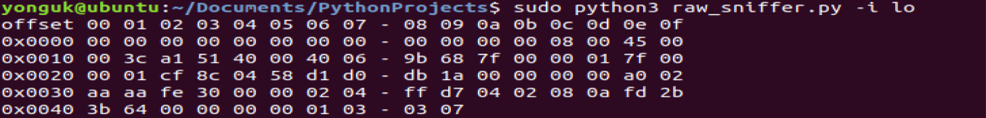

**Wireshark로 분석한 Assignment_2 Server-Client 간의 첫번째 TCP패킷**

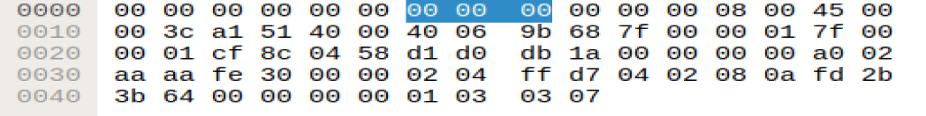

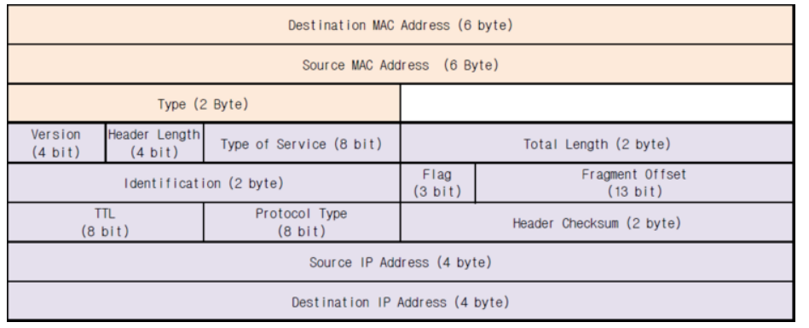

|  |  |  |  |  |  |
| --- | --- | --- | --- | --- | --- |
| Version(4bit)  0100 | Header Length(4bit)  0101 | | Type of service(8bit)  00000000 | Total Length(2byte)  00000000 00111011 | |
| Identification(2byte)  10100001 01010001 | | | | Flag(3bit)  100 | Fragment Offset(13bit)  00000 00000000 |
| TTL(8bit)  01000000 | | Protocol Type(8bit)  00000110 | | Header Checksum(2byte)  10011011 01101000 | |
| Source IP Address(4byte)  01111111 00000000 00000000 00000001 | | | | | |
| Destination IP Address(4byte)  01111111 00000000 00000000 00000001 | | | | | |

IP 패킷 부분의 16진수를 2진수로 바꾼 형태이다.

**TCP 패킷 분석**

: Transmission Control Protocol Version 4

: Internet Protocol Version 4

: Ethernet II

0000 00 00 00 00 00 00 00 00 00 00 00 00 08 00 45 00

Destination MAC Address [00 00 00 00 00 00] Source MAC address [00 00 00 00 00 00]

Type : IPv4 [08 00] [45] 0100 = version : 4 0101 = Header Length : 20 bytes(5)

Differentiated Services Field : 0x00 [00]

0010 00 3c a1 51 40 00 40 06 9b 68 7f 00 00 01 7f 00

Total Length : 60 ([0 3c] Identification : 0xa151(41297) [a1 51] Flags :0x4000 Fragment offset : 0 [40 00] Time to live : 64 [40] Protocol : TCP (6) [06] Header checksum : 0x9b68[validation disabled] [9b 68]

Source : 127.0.0.1 [7f 00 00 01]

0020 00 01 cf 8c 04 58 d1 d0 db 1a 00 00 00 00 a0 02

Destination : 127.0.0.1 [7f 00 00 01] Source Port : 53132 [cf 8c] Destination Port : 1112 [04 58]

Sequence number : 0 [d1 d0 db 1a] Acknowledgment number : 0 [00 00 00 00] Flags : 0x002 (syn) [a0 02]

0030 aa aa fe 30 00 00 02 04 ff d7 04 02 08 0a fd 2b

Window size value : 43690 [aa aa] Checksum : 0xfe30[unverified] [fe 30] Urgent pointer : 0 [00 00]

Options -> TCP option -> Kind : Maximum Segment Size (2) [02] Length : 4 [04] MSS Value:65495 [ff d7]

TCP Option – SACK permitted [04] Length : 2 [02] Kind : time stamp option(8) [08] Length : 10 [0a]

0040 3b 64 00 00 00 00 01 03 03 07)

Timestamp value : 4247468900 [fd 2b 3b 64] Timestamp echo reply : 0 [00 00 00 00]

TCP Option – No-Operation(NOP) Kind : No-Operation(1) [01]

TCP Option – Window scale:7 Kind : Window scale(3) [03] Length : 3 [03] Shift count : 7 [07]